Lecture Programme
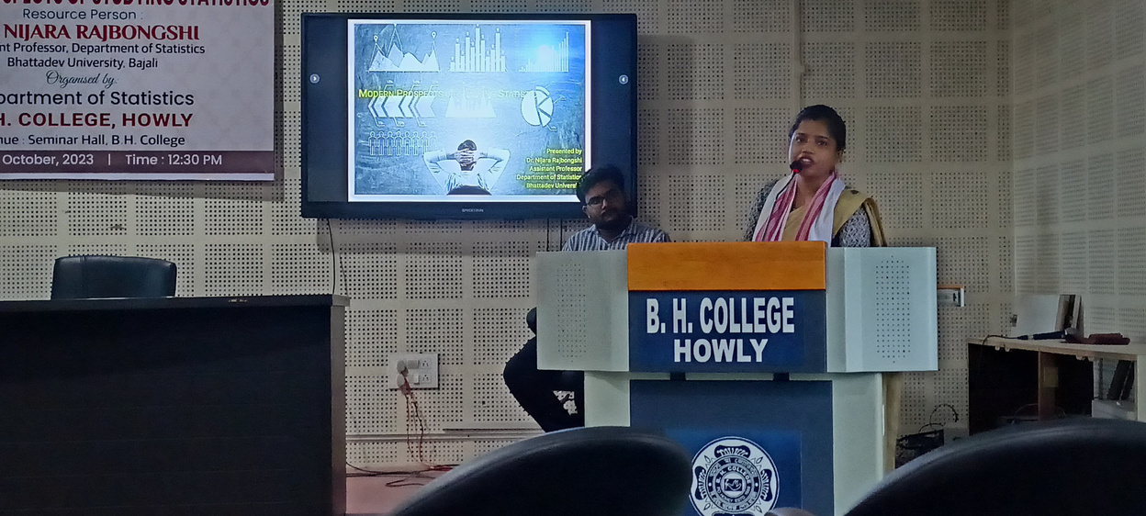

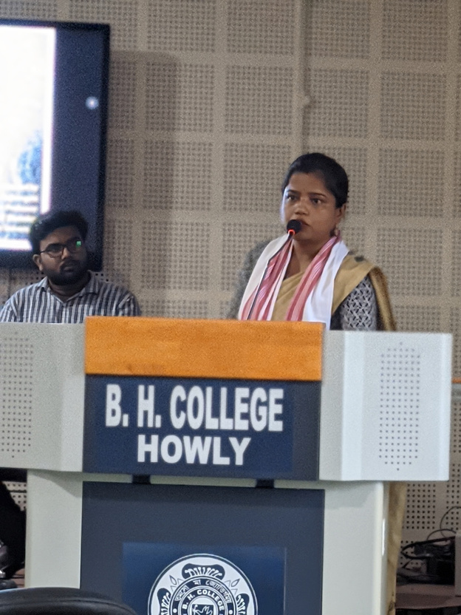

A lecture programme on " Modern Prospects of Studying Statistics " was organized by department of Statistics B .H. College Howly on 4th October, 2023 at 12.30 P.M.. Dr. Nijara Rajbonshi, Assistant Professor, Department of Statistics Bhattadev University , Bajali act as a resource person . This program was held in the seminar hall of th e college . D r. Nijara Rajbonshi gave a valuable talk on importance of studying Statistics for the degree students . She highlighted the different avenues available for Statistics graduates . Her talk also highlights the higher studies available and different job prospects for the students after graduating by taking Statistics as a honours subject. Her lucid and resourceful talk benefited the students a lot. The department is very grateful and thankful to Dr. Nijara Rajbonshi for spending her precious time with us .

